🚖 Uber Trips & Revenue Analysis Dashboard (Power BI)
1. Project Overview
This project presents an interactive Power BI dashboard built to analyze ride-sharing data from Uber.
The dashboard provides insights into rider behavior, revenue trends, vehicle performance, and customer patterns across multiple dimensions.
It is designed with a business-focused approach, enabling stakeholders to make data-driven decisions.

2.  Objectives
- Analyze booking trends (monthly & quarterly)
- Track revenue performance
- Evaluate vehicle category performance
- Understand customer behavior & retention
- Identify cancellation patterns
- Compare payment methods usage
3.  Dashboard Features
-  Home Page
Clean landing page with navigation Modern UI inspired by Uber branding Easy access to all dashboard sections.

-  Overview Dashboard

- 📌 Key Metrics (Overview Dashboard)
- Total Bookings: 93K
- Revenue: 52M
- Lost Bookings: 57K
- Average Distance: 24.64 km
- Total Distance: 2.51M km
- 📅 Time-Based Insights
- January has the highest monthly bookings (8,189)
- Q2 is the strongest quarter (23,268 bookings)
- March generates the highest revenue (4.6M)
- Peak booking time: 6 PM – 9 PM
- 💳 Payment Insights
- UPI is the dominant payment method:
  - Revenue: 23M+
  - Highest number of paying customers: 41K
-  Vehicle Analysis

Vehicle Type | Total Bookings | Revenue | Customers | Cont%
Auto | 23,128 | 12.8M | 32,948 | 100%
Bike | 20,560 | 11.4M | 29,138 | 100%
Go Mini | 18,529 | 10.3M | 28,358 | 100%
Go Sedan | 16,666 | 9.3M | 23,330 | 100%
Premier Sedan | 11,247 | 6.2M | 16,827 | 100%
Uber XL | 2,783 | 1.5M | 4,447 | 100%
- 📌 Insight:
- Auto and Bike dominate volume and revenue
- Uber XL has the lowest demand → niche usage
- Trend indicators using sparklines
-  Revenue Dashboard

- Revenue is 4.57M in march month is highest
- Revenue is 13.07M in 1St Quarter is highest
- Revenue by Auto is 13M
- Revenue by UPI is 23.3M
- Revenue by Customer_id C7828101 is 7.7K

-  Rider Analysis

- 👤 Customer Insights
- Total customers: 104K+ (monthly/quarterly aggregated view)
- Customer Rating: 4.40
- Driver Rating: 4.23
- Rider Segments
- First-time riders
- Return riders
- Regular riders (3+ trips)
📌 Example High-Value Customer:
- Customer ID C7828101
  - Revenue: 7,683
  - Avg Distance: 31.09 km
- ⚠️ Operational Issues
- Customer-related issues: 6,835
- Over-capacity riders: 6,684
- Personal vehicle issues: 6,724
- Sick passenger reports: 6,751
- Missing/blank booking records: 29,942 ⚠️
📌 Insight:
High number of blank/issue records indicates data quality or operational gaps
-  Location Insights (if included)
- Top Pickup Location: Khandsa (~600+ bookings)
- Top Drop Location: Ashram (~592 bookings)
- Busiest Location: Khandsa (~949 bookings)
📌 Distance Trends:
- January distance: 222K km
- Q4 highest distance: 630K km
- Auto contributes highest distance: 0.63M km
- ⏰ Time Slot Analysis
- Peak slot: 6 PM – 9 PM
- Highest demand consistently across all weekdays
📌 Insight:
Evening hours drive the majority of revenue → commuter + leisure demand
4. Tools & Technologies
- Microsoft Power BI Desktop
- DAX (Data Analysis Expressions)
- Data Modeling
- Interactive dashboards (Bookmarks, Filters, Drilldowns)

5.🧠 Key DAX Measures Used
Booking _Count=DISTINCTCOUNT(Uber[Booking ID])

Completed_Booking=CALCULATE([Booking _Count],Uber[Booking Status]="Completed")

Lost_Booking=CALCULATE([Booking _Count],Uber[Booking Status]<>"Completed")

Booking_Value=SUM(Uber[Booking Value])

Total_Distance=SUM(Uber[Ride Distance])

Calender=SUMMARIZE(Uber,Uber[Date])

Month=FORMAT(Calender[Date],"mmm")

Month_Index=MONTH(Calender[Date])

Quarter="Q"&QUARTER(Calender[Date])

Quarter_Index=QUARTER(Calender[Date])

Booking_Remove_Status_Filter = CALCULATE([Booking _Count],ALL(Uber[Booking Status]))

AVG_Distance=AVERAGE(Uber[Ride Distance])

Customer_count=DISTINCTCOUNT(Uber[Customer ID])

Cont% = VAR Vehicle_Remove_filter=CALCULATE([Booking_Value],ALL(Uber[Ve_Type])) VAR Revenue=[Booking_Value] RETURN DIVIDE(Revenue,Vehicle_Remove_filter)

First_Time = COUNTROWS(FILTER(SUMMARIZE(Uber,Uber[Customer ID],"Count",COUNT(Uber[Booking ID])),[Count]=1))

Return_Rider = COUNTROWS(FILTER(SUMMARIZE(Uber,Uber[Customer ID],"Count",COUNT(Uber[Booking ID])),[Count]=2))

Regular_Rider = COUNTROWS(FILTER(SUMMARIZE(Uber,Uber[Customer ID],"Count",COUNT(Uber[Booking ID])),[Count]>=3))

Time_Slot =
VAR _hour = HOUR(Uber[Time])
RETURN
SWITCH(
TRUE(),
_hour >= 9 && _hour < 12, "09AM-12PM",
_hour >= 12 && _hour < 15, "12PM-03PM",
_hour >= 15 && _hour < 18, "03PM-06PM",
_hour >= 18 && _hour < 21, "06PM-09PM",
_hour >= 21 && _hour < 24, "09PM-12AM",
_hour >= 0 && _hour < 3, "12AM-03AM",
_hour >= 3 && _hour < 6, "03AM-06AM",
_hour >= 6 && _hour < 9, "06AM-09AM",
"Blank"
)

Time_Slot_Sort =
SWITCH(
TRUE(),
HOUR(Uber[Time]) >= 0 && HOUR(Uber[Time]) < 3, 1,
HOUR(Uber[Time]) >= 3 && HOUR(Uber[Time]) < 6, 2,
HOUR(Uber[Time]) >= 6 && HOUR(Uber[Time]) < 9, 3,
HOUR(Uber[Time]) >= 9 && HOUR(Uber[Time]) < 12, 4,
HOUR(Uber[Time]) >= 12 && HOUR(Uber[Time]) < 15, 5,
HOUR(Uber[Time]) >= 15 && HOUR(Uber[Time]) < 18, 6,
HOUR(Uber[Time]) >= 18 && HOUR(Uber[Time]) < 21, 7,
HOUR(Uber[Time]) >= 21 && HOUR(Uber[Time]) < 24, 8
)

Weekday_Index = WEEKDAY(Calender[Date], 1)

Weekday = FORMAT(Calender[Date],"ddd")

6.  Dataset
Simulated / sample Uber ride dataset
Includes:
Trip details
Customer data
Vehicle types
Payment methods
Location data

7.  Key Insights
UPI dominates as the most used payment method Auto & Bike categories contribute highest bookingsRevenue remains consistent with slight monthly fluctuations
High number of repeat customers indicates retention strength Cancellations & incomplete rides highlight operational gaps

8.  Business Recommendations
- Reduce Lost Bookings (57K ⚠️)
- Improve driver availability during peak hours
- Introduce dynamic pricing incentives
- Optimize ride allocation algorithm

- Focus on High-Demand Time Slots
- Increase driver supply during 6 PM – 9 PM
- Offer surge incentives for drivers in peak hours

- Strengthen UPI Ecosystem
- Promote cashback/offers on UPI
- Partner with payment providers to increase retention

- Expand in High-Performing Locations
- Increase driver density in Khandsa & Ashram
- Use geo-targeted promotions

- Improve Data Quality
- Investigate 29K blank booking records
- Implement validation checks in data pipeline

- Optimize Vehicle Mix
- Increase Auto & Bike supply (high demand)
- Re-evaluate Uber XL positioning (low usage)
- Customer Experience Improvements
- Address frequent complaints (overcrowding, hygiene)
- Introduce driver quality monitoring system

9. How to Use
- Download the .pbix file from this repository
- Open in Power BI Desktop
- Interact with filters, slicers, and visuals

10. Dashboard Preview

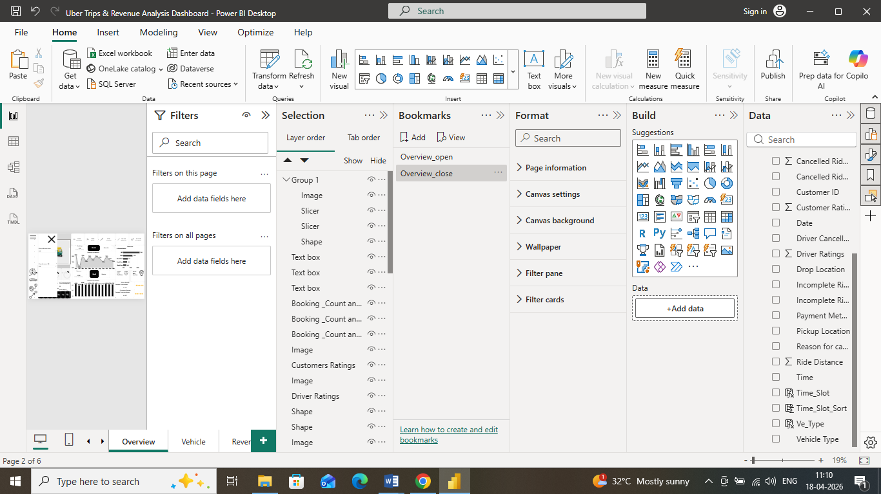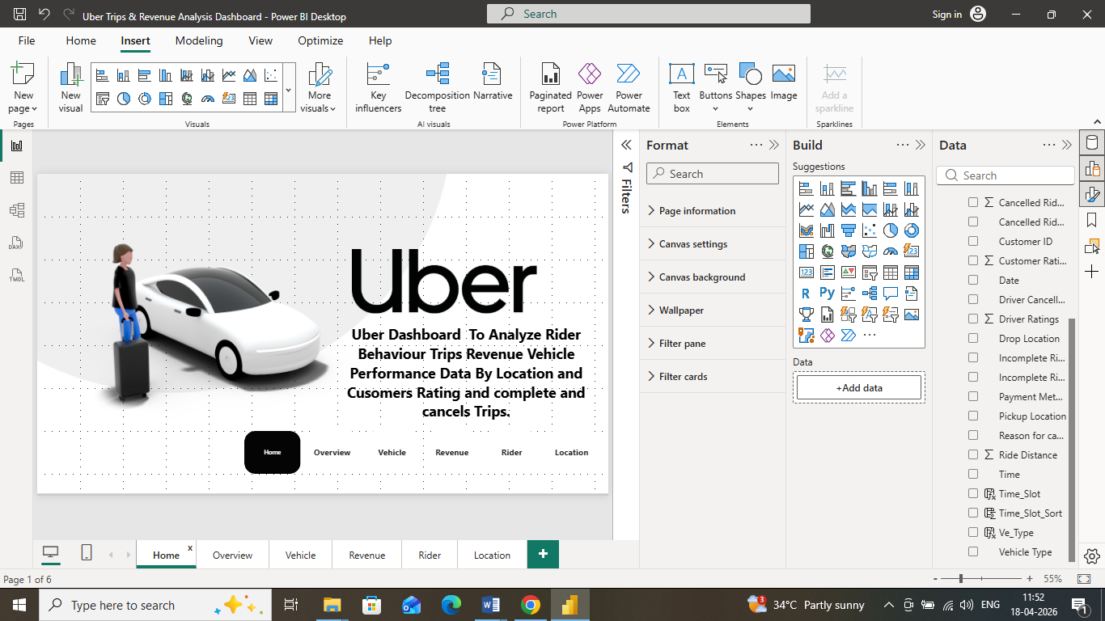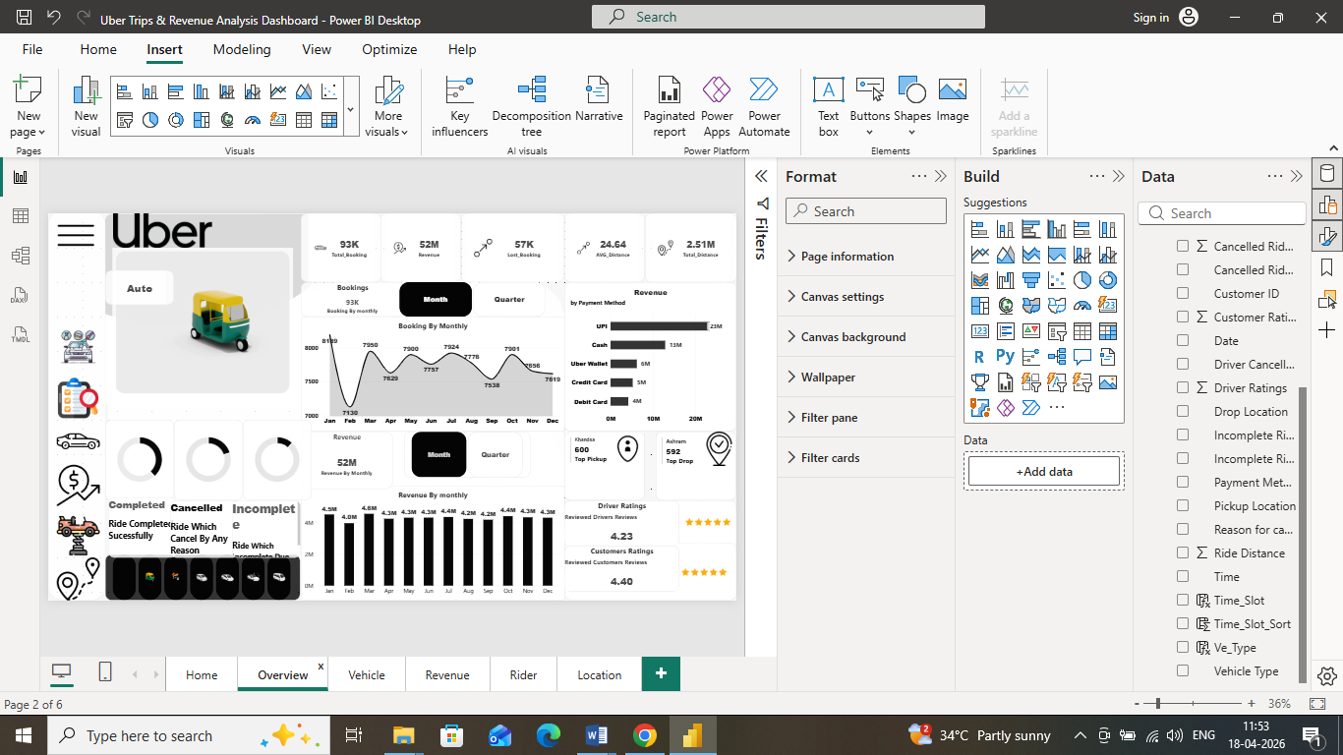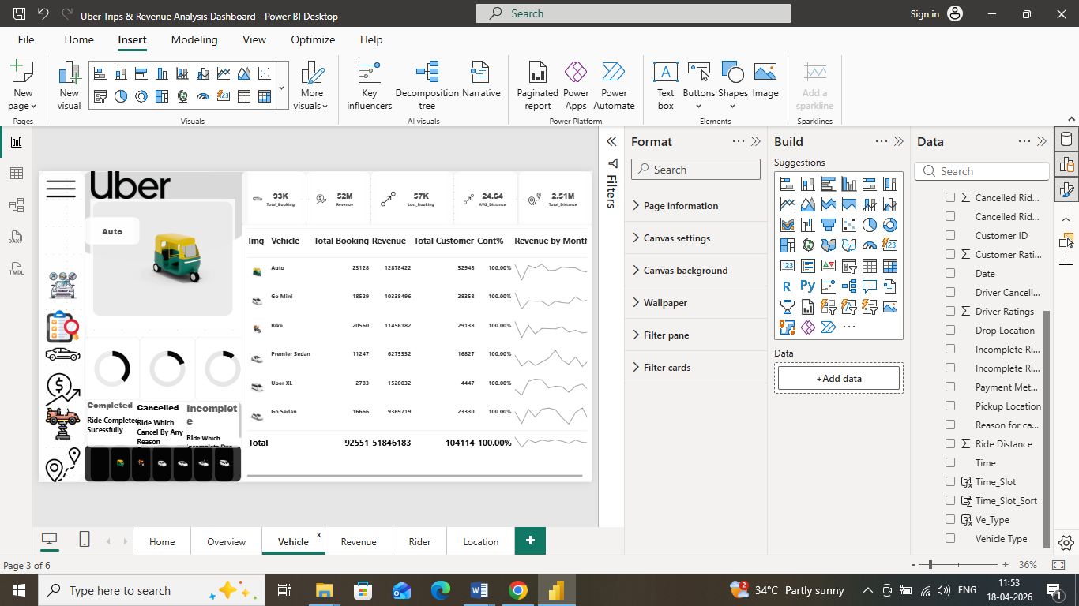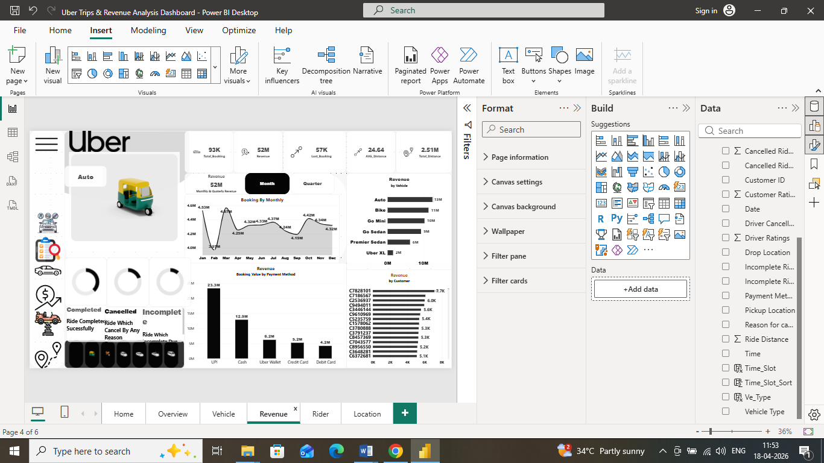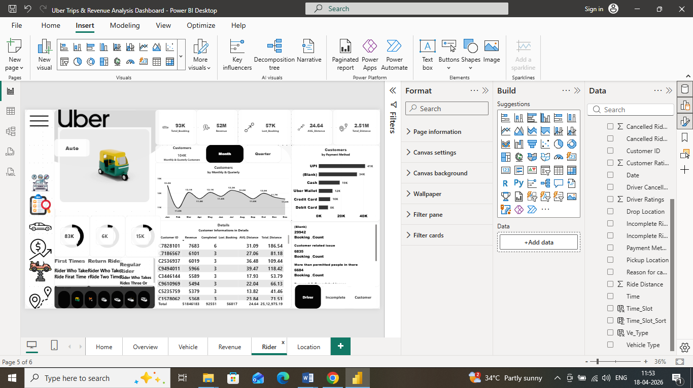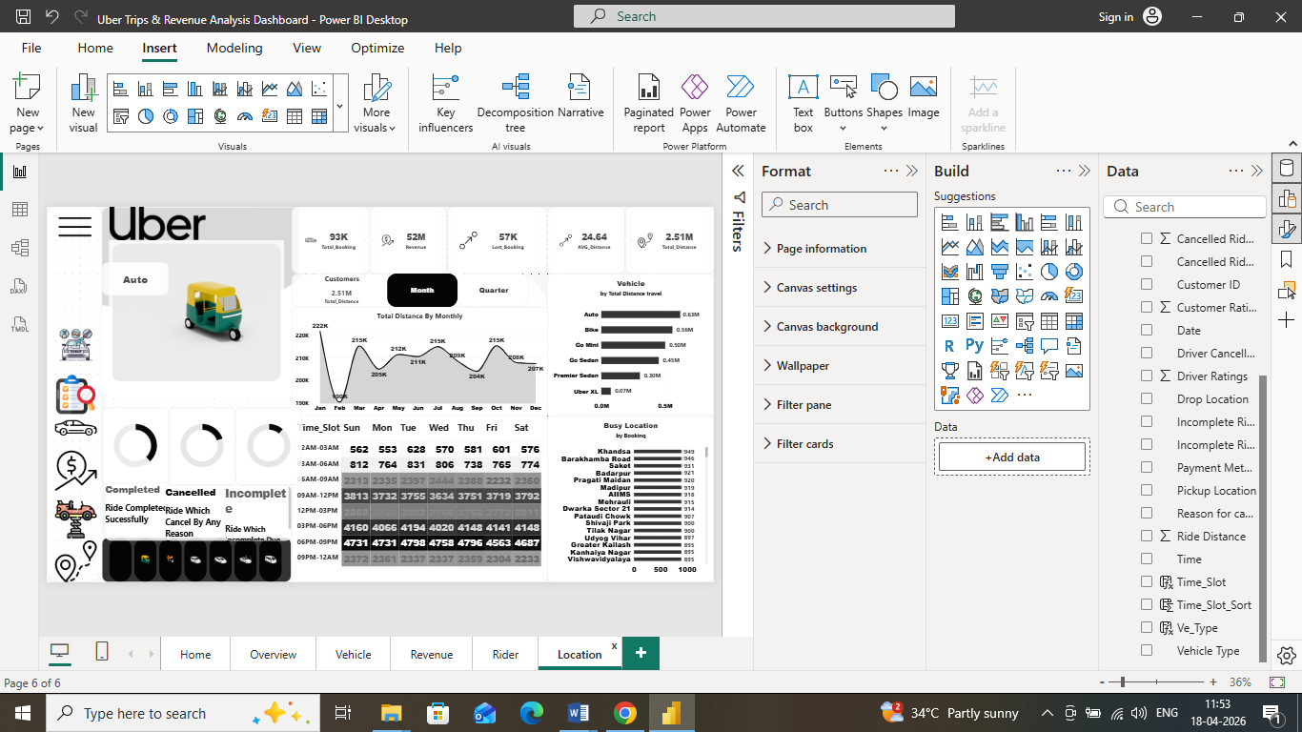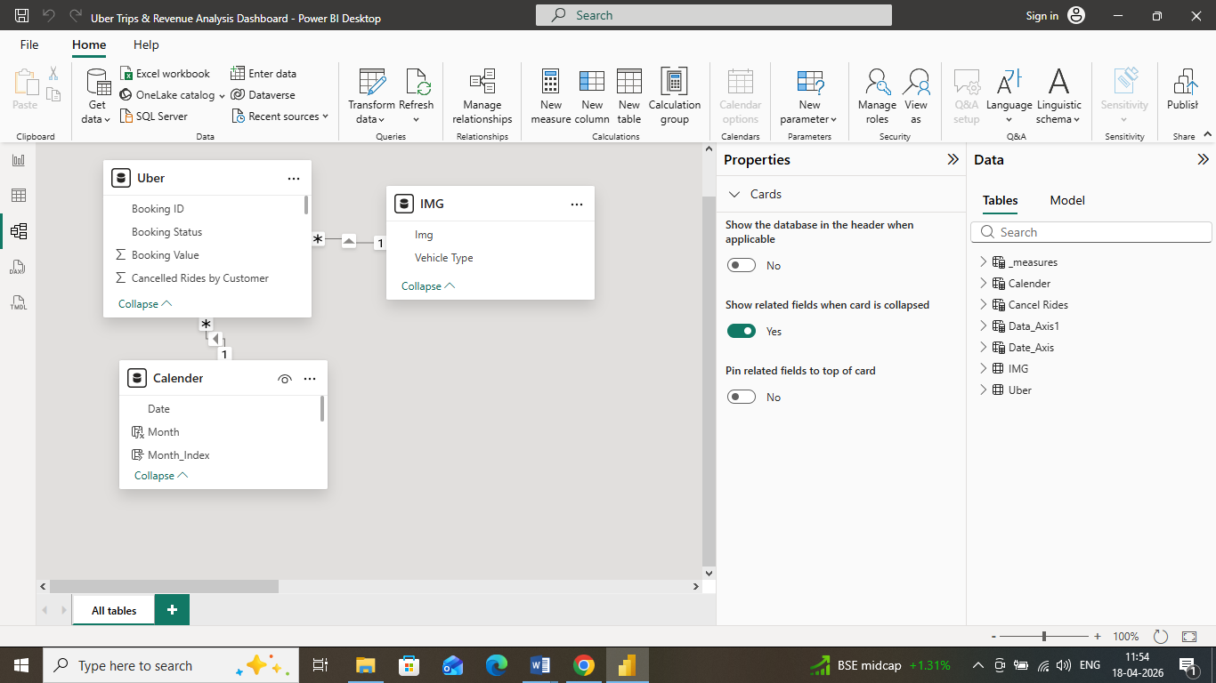

11. 🚀 Conclusion
This dashboard provides a 360° view of Uber operations, highlighting:
- Revenue drivers
- Customer behavior
- Operational inefficiencies
It enables stakeholders to make data-driven decisions to improve efficiency, revenue, and customer satisfaction.
 Contact

Deepak Kumar Tekchandani
Power BI|DAX (Data Analysis Expressions)|Data Modeling|Data Cleaning & Transformation|Interactive Data Visualization
📧 deepakkumartekchandani@gmail.com
🔗 LinkedIn: www.linkedin.com/in/deepak-kumar-tekchandani-b7200a146
💻 GitHub: https://github.com/DTekchandani1/-Uber-Trips-Revenue-Analysis-Dashboard-.git

